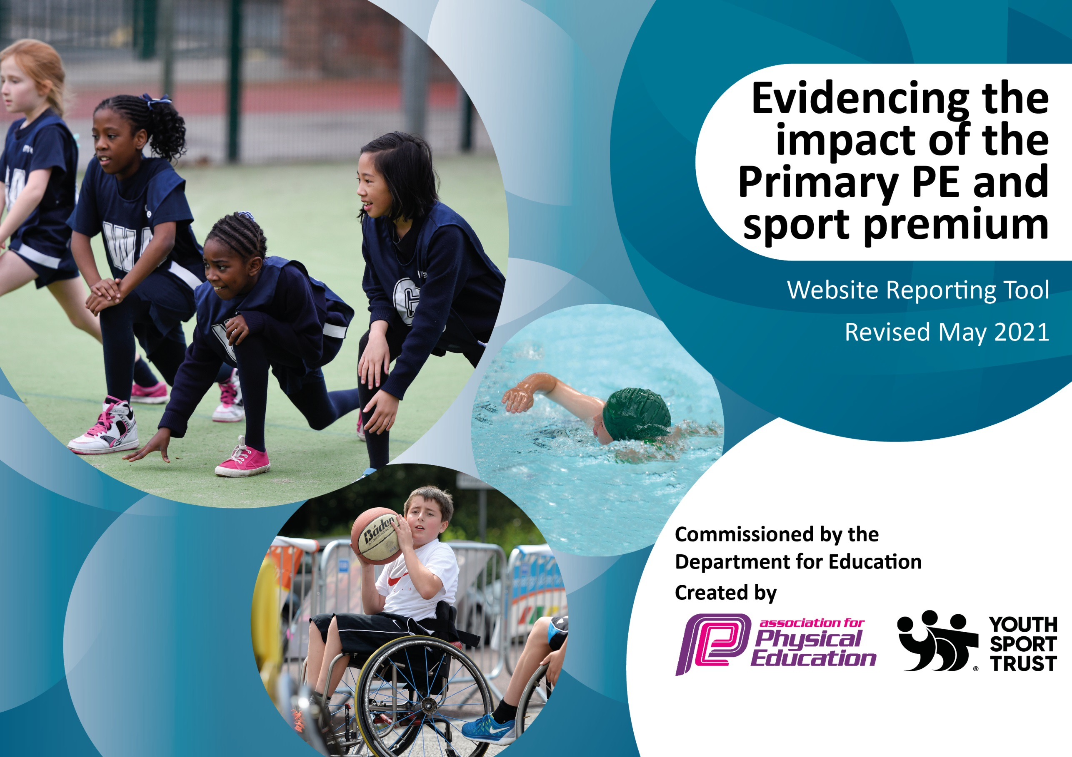

It is important that your grant is used effectively and based on school need. The Education Inspection Framework (Ofsted 2019 p64) makes clear there will be a focus on ‘whether leaders and those responsible for governors all understand their respective roles and perform these in a way that enhances the effectiveness of the school’.

Under the Quality of Education criteria (p41) inspectors consider the extent to which schools can articulate their curriculum (INTENT), construct their curriculum (IMPLEMENTATION) and demonstrate the outcomes which result (IMPACT).

To assist schools with common transferable language this template has been developed to utilise the same three headings which should make your plans easily transferable between working documents.

Schools must use the funding to make additional and sustainable improvements to the quality of Physical Education, School Sport and Physical Activity (PESSPA) they offer. This means that you should use the Primary PE and sport premium to:

- Develop or add to the PESSPA activities that your school already offer
- Build capacity and capability within the school to ensure that improvements made now will benefit pupils joining the school in future years
- The Primary PE and sport premium should not be used to fund capital spend projects; the school’s budget should fund these.
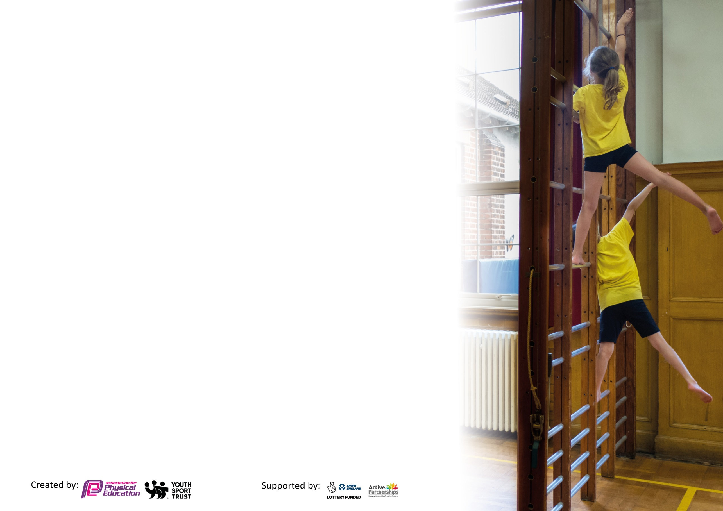
Please visit gov.uk for the revised DfE guidance including the 5 key indicators across which schools should demonstrate an improvement. This document will help you to review your provision and to report your spend. DfE encourages schools to use this template as an effective way of meeting the reporting requirements of the Primary PE and sport premium.

We recommend you start by reflecting on the impact of current provision and reviewing the previous spend.

Schools are required to publish details of how they spend this funding, including any under-spend from 2019/2020, as well as on the impact it has on pupils’ PE and sport participation and attainment by the end of the summer term or by 31st July 2021 at the latest.

We recommend regularly updating the table and publishing it on your website throughout the year. This evidences your ongoing self-evaluation of how you are using the funding to secure maximum, sustainable impact. Final copy must be posted on your website by the end of the academic year and no later than the 31st July 2021. To see an example of how to complete the table please click HERE.



Please note: Although there has been considerable disruption in 2020 it is important that you publish details on your website of how you spend the funding - this is a legal requirement.
Support for review and reflection - considering the 5 key indicators from DfE, what development needs are a priority for your setting and your pupils now and why? Use the space below to reflect on previous spend and key achievements and areas for development.

N.B. In this section you should refer to any adjustments you might have made due to Covid-19 and how these will influence further improvement.
Key achievements to date until July 2021: | Areas for further improvement and baseline evidence of need:
During remote learning, our PE specialist coach, continued to deliver high quality PE lessons for those children in school, alongside setting engaging, skilled PE tasks each week, that were inclusive to all remotely.  During remote learning, all teachers carried out daily PE live lessons with the children. These were engaging, developing new skills and highly attended by all classes.  We participated in the first national ‘England does the Daily Mile’ event. All children and staff took place. Through this, we have introduced regular daily miles to increase exercise levels of the children.  We have introduced alternative sports for the children, including Karate with a specialist teacher.  Class teachers have received weekly CPD sessions with our specialist PE coach, with a particular focus on dance, ball skills and team games.  Dance workshops have taken place, including an African workshop, to engage, motivate and increase enjoyment of dance across the school.  Purchase of PE equipment and resources to enhance the quality of teaching and learning of PE and ensure active playtimes. | Unfortunately, due to class bubbles, we have not been able to introduce Sports leaders in Year 5 and 6 this year. It is our intention to introduce these in the Autumn term, to provide increased sporting opportunities during lunch times.  CPD with our specialist coach, focusing on gymnastics and Tag Rugby (following staff questionnaire.)  Increase participation in inter and intra school competitions.  Wider offer of extra-curricular clubs.  Developing skills of children who are BAR expectations.  Due to COVID, children in Year 4 and 5 have been unable to attend swimming lessons this year, these children to be targeted for lessons next year.

Did you carry forward an underspend from 2019-20 academic year into the current academic year? YES
Total amount carried forward from 2019/2020 £3,574.63
+ Total amount for this academic year 2020/2021 £17,910
= Total to be spent by 31st July 2021 £21,484.63
Meeting national curriculum requirements for swimming and water safety.  N.B Complete this section to your best ability. For example you might have practised safe self-rescue techniques on dry land which you can transfer to the pool when school swimming restarts.  Due to exceptional circumstances priority should be given to ensuring that pupils can perform safe self rescue even  if they do not fully meet the first two requirements of the NC programme of study. | The proportion of children is lower this year, due to not being able to attend swimming lessons due to COVID/ school closures in both academic years 19-20 and 20-21.
What percentage of your current Year 6 cohort swim competently, confidently and proficiently over a distance of at least 25 metres?  N.B. Even though your pupils may swim in another year please report on their attainment on leaving primary school at the end of the summer term 2021.  Please see note above. | 71%
What percentage of your current Year 6 cohort use a range of strokes effectively [for example, front crawl, backstroke and breaststroke]?  Please see note above. | 65%
What percentage of your current Year 6 cohort perform safe self-rescue in different water-based situations? | 71%
Schools can choose to use the Primary PE and sport premium to provide additional provision for swimming but this must be for activity over and above the national curriculum requirements. Have you used it in this way? | We had planned to, however due to COVID children were unable to attend. They will have the sessions in 21/22 instead.

Action Plan and Budget Tracking
Capture your intended annual spend against the 5 key indicators. Clarify the success criteria and evidence of impact that you intend to measure to evaluate for pupils today and for the future.

Academic Year: 2020/21 | Total fund allocated: £21,484 (due to COVID restrictions there will be a carry forward into 21-22.) | Date Updated: July 2021
Key indicator 1: The engagement of all pupils in regular physical activity – Chief Medical Officers guidelines recommend that primary school pupils undertake at least 30 minutes of physical activity a day in school |  |  |  | Percentage of total allocation:
 |  |  |  | 12%
Intent | Implementation |  | Impact
Your school focus should be clear what you want the pupils to know and be able to do and about  what they need to learn and to  consolidate through practice: | Make sure your actions to achieve are linked to your intentions: | Funding allocated: | Evidence of impact: what do pupils now know and what can they now do? What has changed?: | Sustainability and suggested next steps:
Replacement of identified faulty playtime or PE equipment, as well as purchase of necessary new resources to deliver a high quality PE curriculum through the school. Equipment will also be used for ensure active play times for children.  Purchase of PE equipment to support the physical development and the transition of this area in Yr 1 for the Autumn term. | Improved resourcing for PE, and prescribed curriculum content.  Raise pupil engagement and application within lessons.  Improve quality of recreational play during lunchtimes.  Enhance pupil fitness levels and enjoyment of active healthy lifestyles.  To improve the PE skills our current Year 1 class, whose fine and motor skills have been impacted by school closure Summer 20. | £1000  £472 | Wider range of sports specific activities at lunchtime for all children.  Higher levels of engagement and application evident within lessons.  A clear improvement in the children’s coordination, control and movement is evident.  Children are engaged in PE activities. | Ongoing termly check to maintain levels off equipment to allow children to keep as active as possible.  Storage of equipment to ensure longevity.
Additional swimming session for Year 4 to have a terms worth of swimming,  (Year 5 currently attend as part of school curriculum.) | Improve children’s confidence in the water.  A higher proportion of children to meet the 25m target by the end of Year 6. | £1188 | Children unable to attend due to COVID, sessions have been booked in for 21/22 year instead.
Key indicator 2: The profile of PESSPA being raised across the school as a tool for whole school improvement |  |  |  | Percentage of total allocation:
 |  |  |  | 4%
Intent | Implementation |  | Impact
Your school focus should be clear what you want the pupils to know and be able to do and about  what they need to learn and to  consolidate through practice: | Make sure your actions to achieve are linked to your intentions: | Funding allocated: | Evidence of impact: what do pupils now know and what can they now do? What has changed?: | Sustainability and suggested next steps:
Annual subscription to PE hub.  Access for all staff to up to date schemes of work, lesson plans, videos and resources that are continually updated.  Lesson ideas and resources for all areas of the curriculum, including new sports introduced into the curriculum e.g. Handball.  Online PE discussion forums and blogs to help teachers with planning and delivering successful lessons. | Ensure subscription is renewed.  Staff meeting time to remind staff about its use and resources available. Remind staff of their log in details, and monitor use of scheme of work with staff.  Autumn 20- all classes to follow distance PE sessions to ensure social distancing is taking place. | £455 | Upskilling of staff.  Increase staff confidence with the delivery of PE lessons.  Supporting staff with the delivery of PE during remote learning.  Curriculum planning secure and updated regularly.  Improved planning, assessment and delivery of lessons. | Planning resources in place and regular updates made to existing resources.
Buy into the Sports leaders ‘Play maker’ award for year 5&6 pupils to carry out lunch time activities. | Sign up for the play maker award.  Carry out an assembly with Year 5 and 6 to explain the role of a play maker, and speak with children that are interested in the role.  Support children with carrying out the role. | £99 | Unfortunately, due to COVID, children have been unable to mix bubbles and carry out these activities. It is intended to ensure this is up and running again in Autumn 21.
Medal/Trophies to recognise and praise sporting  Achievement, effort and team working skills.  Sports assemblies. | Purchase of medals and trophies.  Organise sports assemblies. | £200 | Medals and trophies have been distributed during sports day to praise achievements of children. This has increased children’s love of sport.  During assemblies, sport achievements have been praised. This has encouraged children to share their PE sporting achievements, both within and outside of school. | Regularly update resources.  Children are inspired to take part in sport as well as developing positive sporting attributes.

Key indicator 3: Increased confidence, knowledge and skills of all staff in teaching PE and sport |  |  |  | Percentage of total allocation:
 |  |  |  | 76%
Intent | Implementation |  | Impact
Your school focus should be clear | Make sure your actions to | Funding | Evidence of impact: what do | Sustainability and suggested
what you want the pupils to know | achieve are linked to your | allocated: | pupils now know and what | next steps:
and be able to do and about | intentions: |  | can they now do? What has
what they need to learn and to |  |  | changed?:
consolidate through practice:
Employment of external specialist coach at Teach Sport to up skill staff and to develop their confidence and ability to lead a range of sports to a higher level. Dedicated lessons focusing on team teaching with coach. | To identify areas of CPD required. Timetable staff into these sessions. Monitor CPD sessions taking place and oversee class teachers using the knowledge they have learnt to provide classes with high quality physical activity lessons. Encourage to feed back the knowledge and skills developed during staff meetings. | £14,814 | From discussions/questionnaires with staff, they feel more confident with delivering PE lessons.  Check ins during PE lessons, shows an improvement in the quality of PE lessons being delivered by staff. | Staff questionnaires for staff to share other areas of the PE curriculum they would find CPD beneficial for.  Teachers working with specialist coach to developing their planning of these areas for next year’s teaching.
PE subject leader release time.  To monitor, support, and deliver high quality PE lessons throughout the school. | To carry out staff meetings/any CPD.  Team teach lessons.  Support teachers in the planning and delivery of lessons.  Organise competitions and whole school events. | £1477 | Has organised whole school sporting events e.g. national daily mile event.  Supported teachers in the delivery of high quality PE lessons. | As above.
Key indicator 4: Broader experience of a range of sports and activities offered to all pupils |  |  |  | Percentage of total allocation:
 |  |  |  | (money has been allocated within KI2 for both points below.)
Intent | Implementation |  | Impact
Your school focus should be clear | Make sure your actions to | Funding | Evidence of impact: what do | Sustainability and suggested
what you want the pupils to know | achieve are linked to your | allocated: | pupils now know and what | next steps:
and be able to do and about | intentions: |  | can they now do? What has
what they need to learn and to |  |  | changed?:
consolidate through practice:
PE Hub  Introduction of Handball into our PE curriculum. | See Key indicator 2 | See Key indicator 2 | See key indicator 2 | See key indicator 2  Year 21/22 look at introducing lacrosse.
Employment of PE specialist coach, to deliver a half term of Karate to the children | Discuss with PE coach equipment required to carry out lessons. | (part of money from Teach sport allocation in Key indicator 2) | Children learning a new sport.  Children learning discipline, self-restraint and control. | Children encouraged to attend local karate club.

Key indicator 5: Increased participation in competitive sport |  |  |  | Percentage of total allocation:
8%
(money being brought forward to 21/22)
Intent | Implementation |  | Impact
Your school focus should be clear | Make sure your actions to | Funding | Evidence of impact: what do | Sustainability and suggested
what you want the pupils to know | achieve are linked to your | allocated: | pupils now know and what | next steps:
and be able to do and about | intentions: |  | can they now do? What has
what they need to learn and to |  |  | changed?:
consolidate through practice:
Membership of Borough SGO inter competition package.  Membership to Orpington and District FA. | Sign up for the package. Sign up for different competitions taking place throughout the year.  Sign up for membership this year. Organise matches | £350  £50 | Due to COVID, these competitions have been unable to take place. | Autumn 21, sign up for packages for year 21/22.
Transport for competitions, to increase participation. | Organise taxis to take school staff and children to competitions. | £200 | Due to COIVD, have been unable to attend competitions.
Teaching assistants to run and manage school football teams and take children to competitions out of school hours.  New boys and girls football kits to be ordered. | Organise date and time for sessions. Make sure children have correct clothing.  Select and order kits. | £1179 | Due to COVID, have been unable to attend competitions. | Order football kits Autumn 21, to wear at competitions for year 21/22.

